# TOPIC

Determinants of Mexican Bank’s Profitability

# LITERATURE REVIEW

Contenido

TOPIC 1

LITERATURE REVIEW 2

MPS AND EQUITY PRICES 3

Adelopo, Ismail; Nikolina, Vichou & Kwok Yip, Cheung (2021) 3

# MPS AND EQUITY PRICES

Capital, liquidity, and profitability in European banks

Adelopo, Ismail; Nikolina, Vichou & Kwok Yip, Cheung (2021)

**Abstract**

The research aims to investigate the impact of increased capital requirements and high liquidity levels on the profitability of European banks in the post crisis period. The study examines the largest banks in the European Union spanning 28 countries using data from 2010 to 2018. It used three measures to define bank profitability: return on average assets, return on average equity, and operating profit to risk weighted assets. Capital, liquidity, size, and asset quality represent bank specific determinants, while economic growth and inflation are considered as the main external determinants having influence on profitability. We used multiple regression models to analyze the association amongst the variables. The results revealed a positive and significant association between liquidity level and bank performance. Asset quality showed a negative and statistically significant influence on bank performance, while economic growth and inflation have no significant influence on bank performance. The study concludes that there is limited influence of the Basel III on bank profitability although the policy is important in achieving banking stability. This study contributes to the literature by empirically analyzing the impact of capital regulation on bank performance for the biggest banks in Europe. Although the Basel III framework is important for prudential banking, its effects on the performance of European bank is debatable.

**Data**

Capital

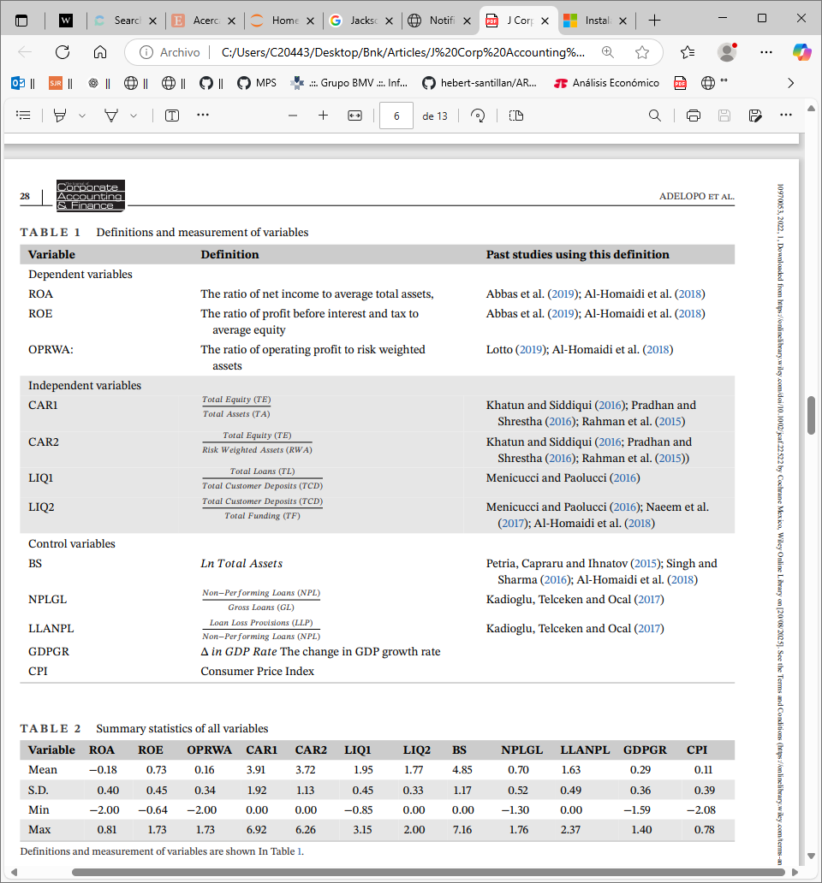

**Methodology**

Regression of each bank profitability variable (ROE, ROA, OPRWA) specified as

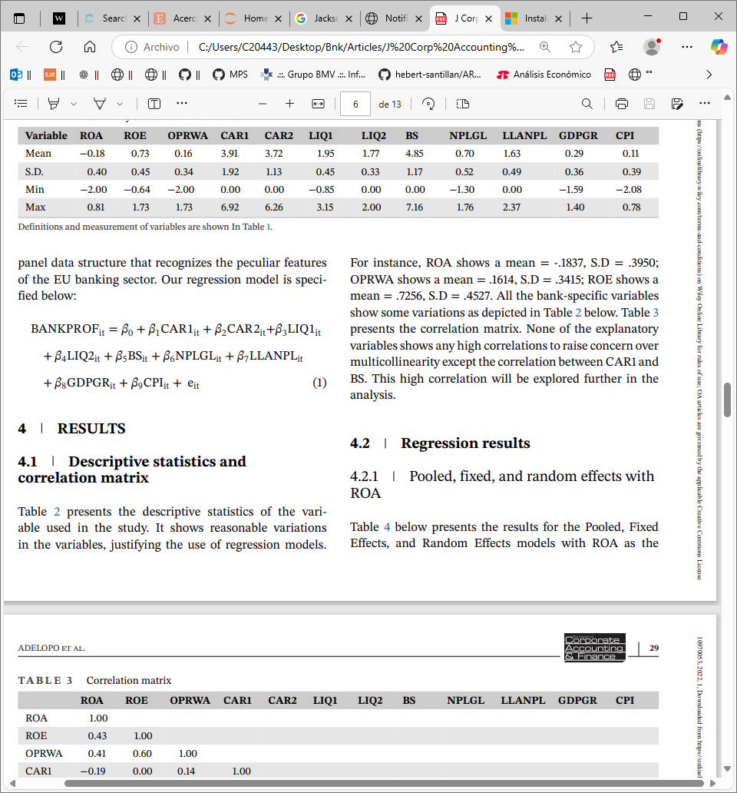

**Results**